**PROJECT REPORT TEMPLATE**

**A GLOBAL CO2 EMISSION ANALYSIS**

**1.INTRODUCTION:**

**OVERVIW:**

Carbon dioxide emissions or CO2 emissions are emissions stemming from the burning of fossil fuels and the manufacture of cement; they include carbon dioxide produced during consumption of solid, liquid, and gas fuels as well as gas flaring. CO2 can also be emitted from direct human-induced impacts on forestry and other land use, such as through deforestation, land clearing for agriculture, and degradation o**f soils.**

PURPOSE:

This report discusses the results of a trend assessment of global CO2 emissions up to 2011 and updates last year's assessment. This assessment focusses on the changes in annual CO2 emissions from 2010 to 2011, and includes not only fossil fuel combustion on which the BP reports are based, but also incorporates all other relevant CO2 emissions sources including flaring of waste gas during oil production, cement clinker production and other limestone uses, feedstock and other non-energy uses of fuels, and several other small sources. After a short description of the methods used (Chapter 2), we first present a summary of recent CO2 emission trends, by region and by country, and of the underlying trend of fossil fuel use, non-fossil energy and of other CO2 sources (Chapter 3). To provide a broader context of the global trends we also assess the cumulative global CO2 emissions of the last decade, i.e. since 2000, and compare it with scientific literature that analyse global emissions in relation to the target of 2C maximum global warming in the 21st century, which was adopted in the UN climate negotiations (Chapter 4). Compared to last year's report, Annex 1 includes a more detailed and updated discussion.

Future CO2 emissions from China's industrial sector have been explored in many publications. Here this study performs a meta-analysis to explore the potential range of predictions and the most robust estimates. Detailed information on the models and methods used for these projections from the literature are available in SI .

2.PROBLEM DEFINITION &DESIGN THINKING:

**EMPATHY MAP:**

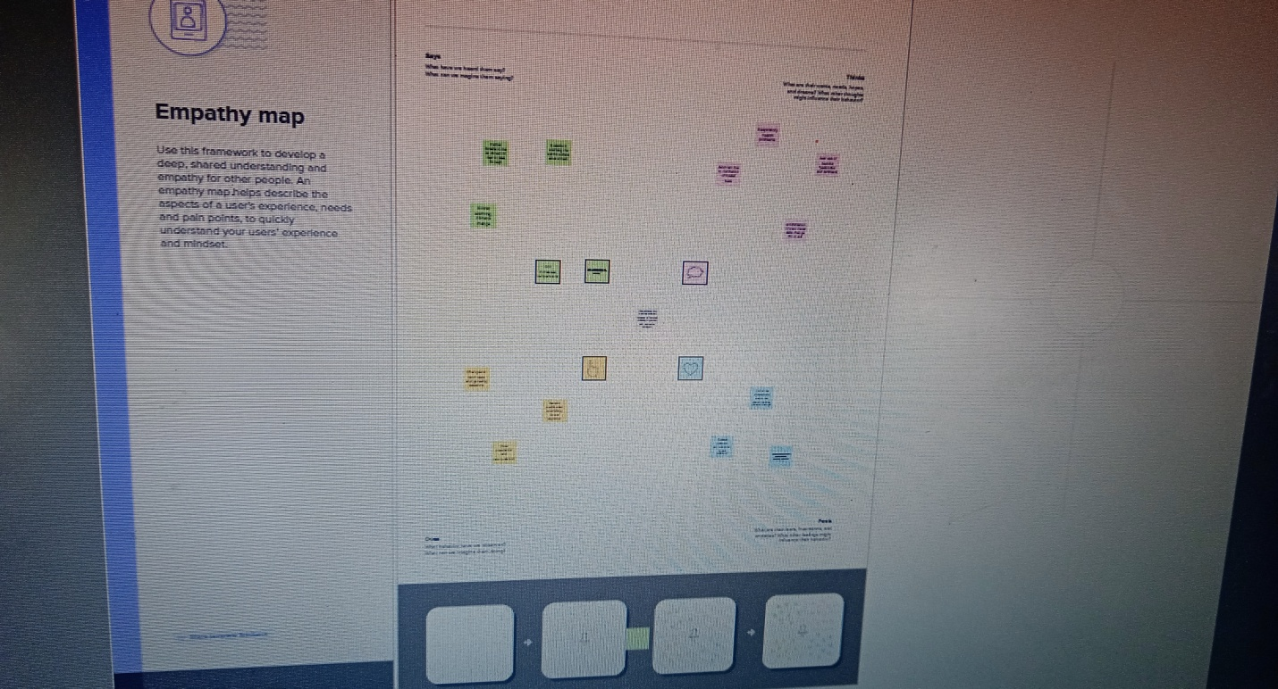

**BRAINSTORM:**

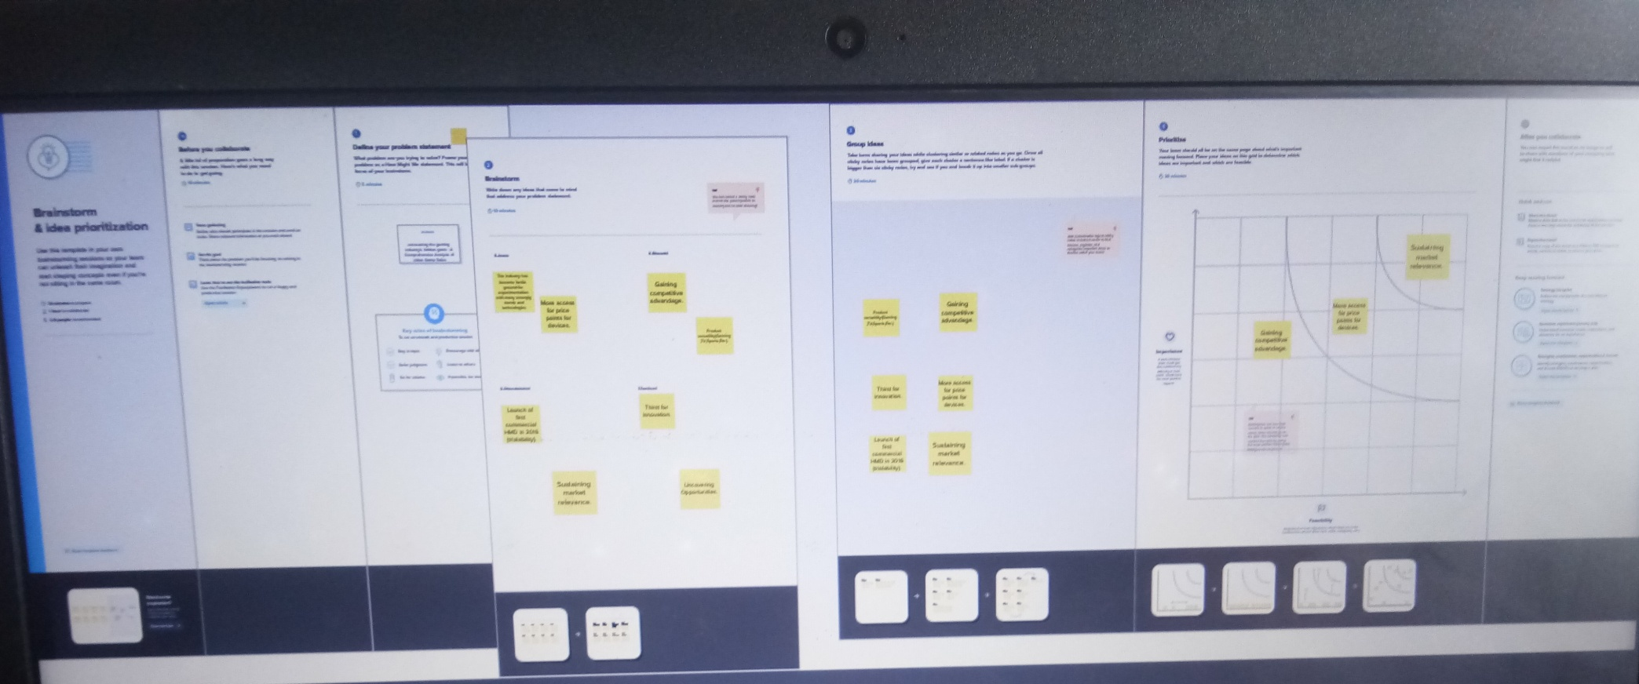

**3.RESULT(OUTPUT SCREENSHOTS):**

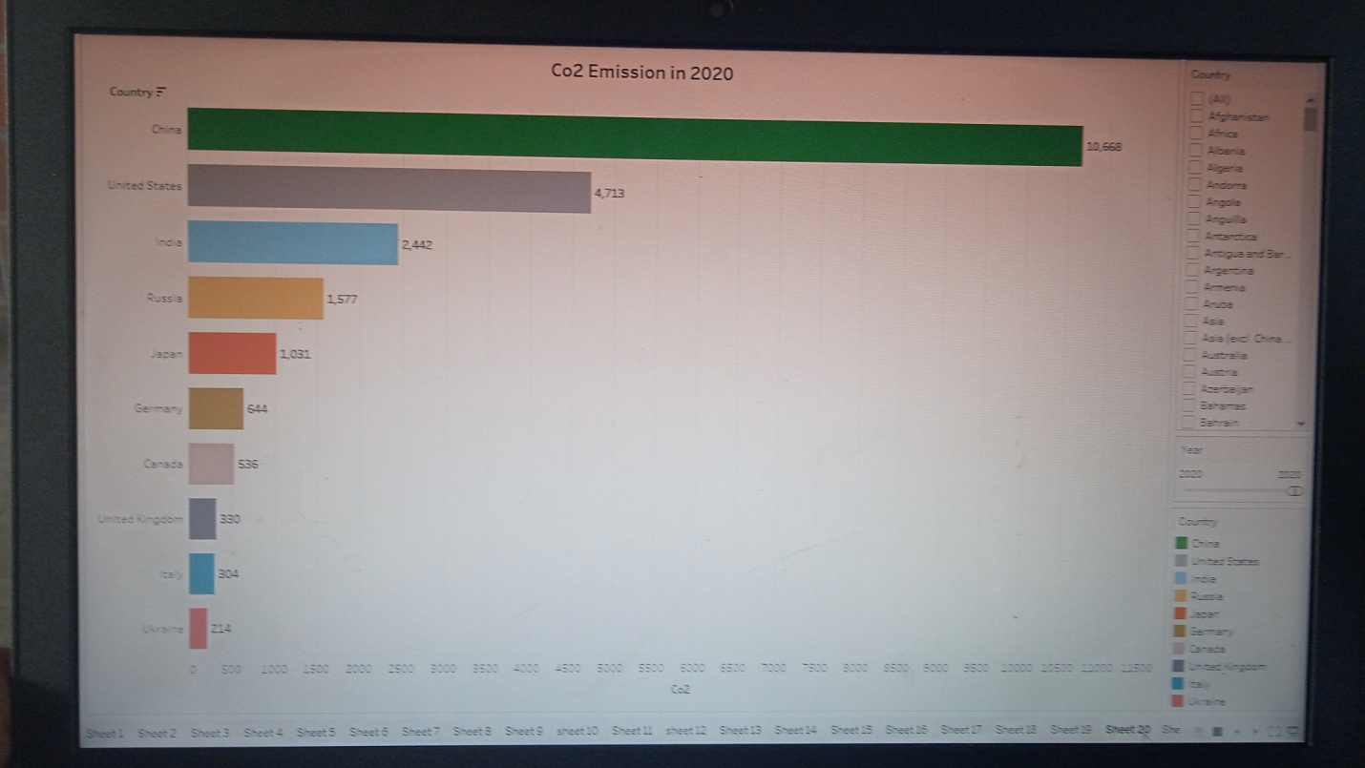

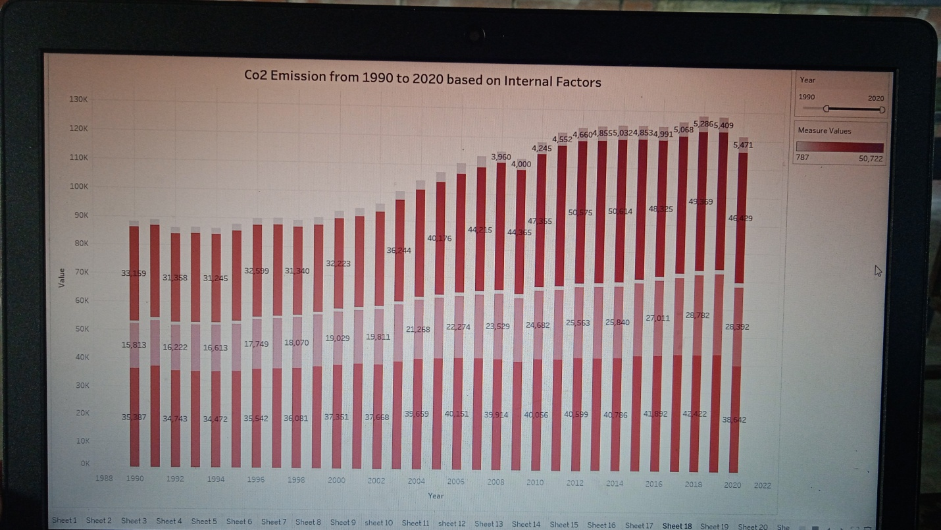

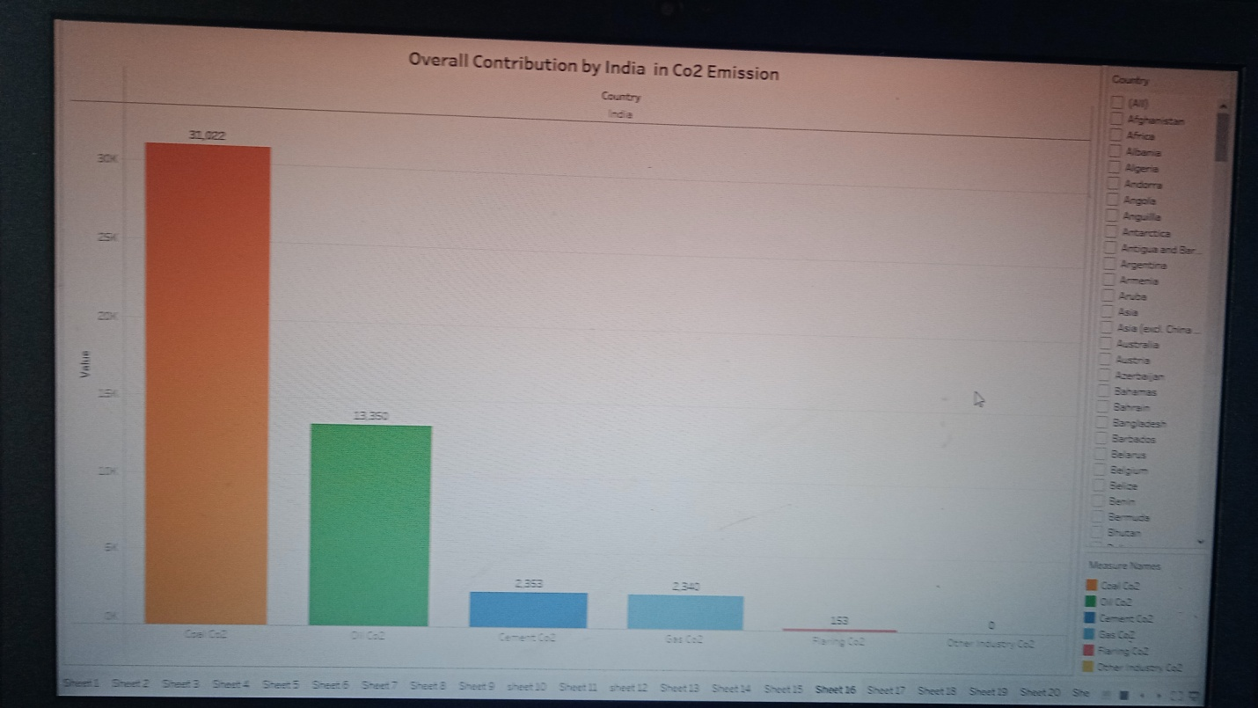

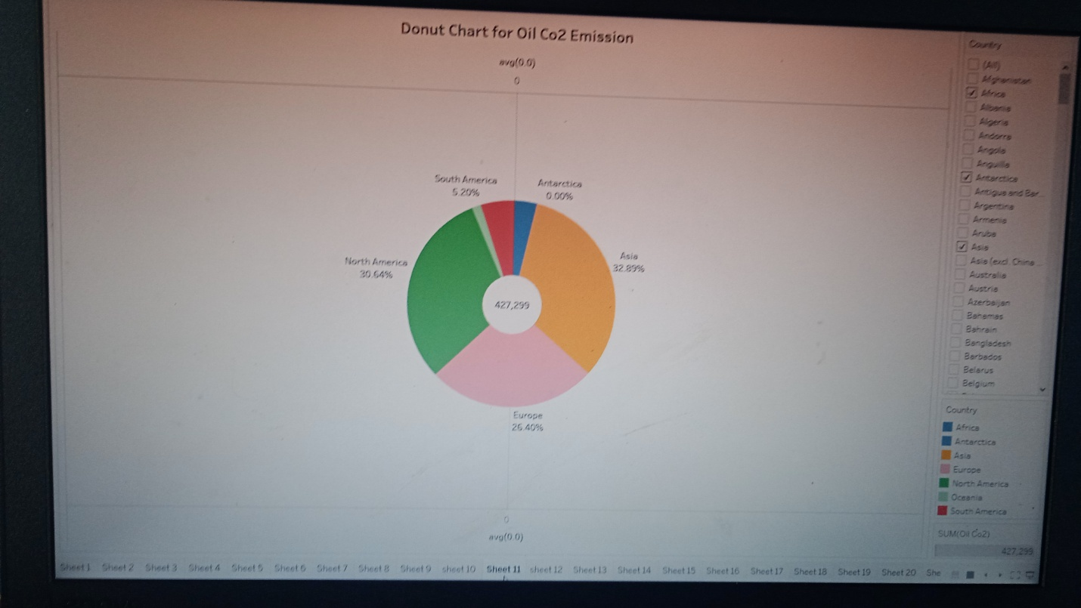

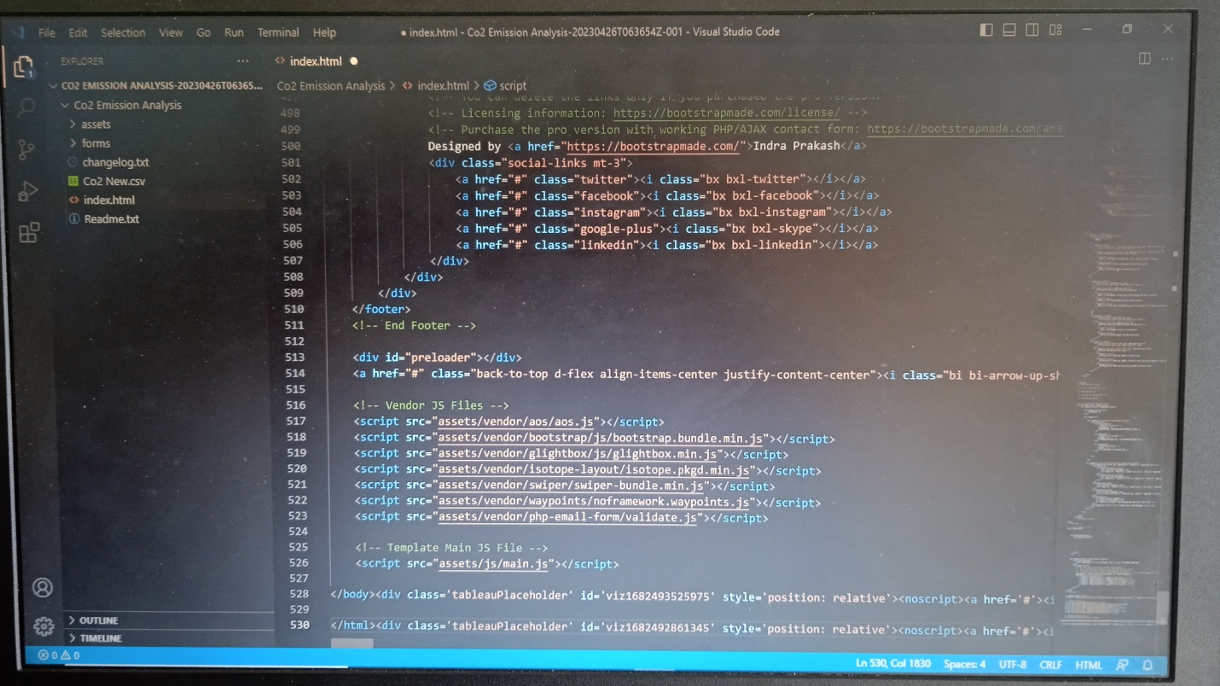

**4.ADVANTAGES & DISADVANTAGES:**

High CO2 levels, generally over 1000 ppm, indicate a potential problem with air circulation and fresh air in a room or building. In general, high CO2 levels indicate the need to examine the HVAC system. High carbon dioxide levels can cause poor air quality and can even extinguish pilot lights on gas-powered appliances.

Clearer Air & Skies – reducing our carbon emissions helps reverse the impact of global warming overall, but more specifically, benefits the overall air quality. Plus, it makes for clearer skies! 2. Save Money – the simple reduction of energy shrinks your carbon footprint and operating expenses

.

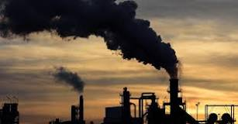

the rising of sea levels, the disturbance of animals' natural habitats, extreme weather The amount of carbon emissions trapped in our atmosphere causes global warming, which causes climate change, symptoms of which include melting of the polar ice caps, events, and so many more negative side effects that are dangerous .

These may include headaches, dizziness, restlessness, a tingling or pins or needles feeling, difficulty breathing, sweating, tiredness, increased heart rate, elevated blood pressure, coma, asphyxia, and convulsions.

Limiting the global average temperature rise to no more than 1.5°C above pre-industrial levels will require all sectors of the economy to reach zero carbon dioxide (CO2) emissions early in the second half of this century.

5.APPLICATIONS:

Increasing concern about carbon dioxide (CO2) emission reduction demands knowledge about the production structure of an economy. Information on productive linkages yields insight about forward and backward emission effects associated with [sectoral](https://www.sciencedirect.com/topics/engineering/sectoral) inputs and outputs and serves as an essential starting point to identify the optimised industrial structure under the constraint of CO2 emission. This paper proposes a combined linkage analysis and multi-objective programming approach to identify the key CO2 emission sectors and the optimised production structure with respect to emission reduction target. As a demonstration, the proposed approach is applied to data from China in 2007. The result shows that to reduce CO2 emissions from 5707.16 to 5452.12 million tonnes, China needs to change its industrial structure by focussing on industrial groups as defined by linkage characteristics, which would lead to a subsequent GDP decrease of 82.59 billion Yuan. From a policy standpoint, the analytical techniques described in this paper can provide valuable information for planners and [decision makers](https://www.sciencedirect.com/topics/engineering/decision-maker) to formulate feasible and practical industrial polices with implications for CO2 emissions.

In the literature on linkage analysis, backward and forward linkages (BL and FL, respectively) are widely accepted concepts to describe inter-sectoral relationships and identify key sectors. The pioneering work of Chenery and Watanabe, 1958, Rasmussen, 1956 and Hirschman (1958) on the use of linkages to compare international productive structures led to a growing body of theoretical and empirical literature (Jones, 1976, Cella, 1984, Clements, 1990, Dietzenbacher, 1992, Sonis et al., 1995, Dietzenbacher and van der Linden, 1997, Sonis and Hewings, 1999, Tzouvelekas, 2002, Adamou, 2004, Andreosso-O'Callaghan and Yue, 2004, Cai et al., 2005). Currently, linkage analysis has been extended to address growing environmental concerns, such as pollutant emissions and natural resource usage. Several papers deserve mention here: Lenzen (2003) generalised the traditional work on linkages by including environmental and natural resource parameters and identified the environmentally important linkages and key sectors in theAustralian economy. Sánchez-Chóliz and Duarte (2003) similarly identified key sectors in generating water pollution in the Aragonese economy through the use of vertical integration methodology. Sánchez-Chóliz and Duarte (2005) proposed to use linkage indicators to examine the relationships between the production structure and water pollution in Spain. Tarancon and del Río (2007) used a combined input–output and sensitivity analysis approach to analyse key sectors and relevant transactions in CO2 emissions in Spain. The results emerging from these generalised linkages yield insight about forward and backward resource use and pollutant emission effects associated with sectoral inputs and outputs; however, a main drawback of linkage analysis is its overly simplified approach to development policy (Bharadwaj, 1966, Panchamuk1975, McGilvray, 1977). As a consequence, linkage analysis is usually used as a descriptive rather than empirical tool (Lenzen, 2003).

6.CONCLUSION:

Publications containing historical energy statistics make it possible to estimate fossil fuel CO2 emissions back to 1751. Etemad et al. (1991) published a summary compilation that tabulates coal, brown coal, peat, and crude oil production by nation and year. Footnotes in the Etemad et al.(1991) publication extend the energy statistics time series back to 1751. Summary compilations of fossil fuel trade were published by Mitchell (1983, 1992, 1993, 1995). Mitchell's work tabulates solid and liquid fuel imports and exports by nation and year. These pre-1950 production and trade data were digitized and CO2 emission calculations were made following the procedures discussed in Marland and Rotty (1984) and Boden et al. (1995). Further details on the contents and processing of the historical energy statistics are provided in Andres et al. (1999).

The 1950 to present CO2 emission estimates are derived primarily from energy statistics published by the United Nations (2009), using the methods of Marland and Rotty (1984). The energy statistics were compiled primarily from annual questionnaires distributed by the U.N. Statistical Office and supplemented by official national statistical publications. As stated in the introduction of the Statistical Yearbook, "in a few cases, official sources are supplemented by other sources and estimates, where these have been subjected to professional scrutiny and debate and are consistent with other independent sources." Data from the U.S. Department of Interior's Geological Survey (USGS 2009) were used to estimate CO2 emitted during cement production. Values for emissions from gas flaring were derived primarily from U.N. data but were supplemented with data from the U.S. Department of Energy's Energy Information Administration .